|  |  |
| --- | --- |
| **NAME :** | VARSHAPRAKALYA.V.P |
| **DEPARTMENT :** | INDUSTRIAL BIOTECHNOLOGY |
| **COLLEGE :** | GOVERNMENT COLLEGE OF TECHNOLOGY |
| **NAAN MUDHALVAN COURSE:** | DIGITAL MARKETING |
| **NAAN MUDHALVAN ID :** | 9C6C2170BD49141819040B6400FE6395 |

ASSIGNMENT ON DIGITAL MARKETING

1. Create a blog or website using blogspot and wordpress.Customize the theme design and post new article with 500 Words.

<https://www.canva.com/design/DAFwT2S-7oM/infnKNYe1WdvXkptXmxUgA/edit?utm_content=DAFwT2S-7oM&utm_campaign=designshare&utm_medium=link2&utm_source=sharebutton>

<https://wordpress.com/post/entertainment6725.wordpress.com/3>

2.Create a new facebook business page and post one social media poster for your brand.

<https://www.facebook.com/profile.php?id=61552087138226&mibextid=ZbWKwL>

3, Create and design a social media advertisement poster using canva.

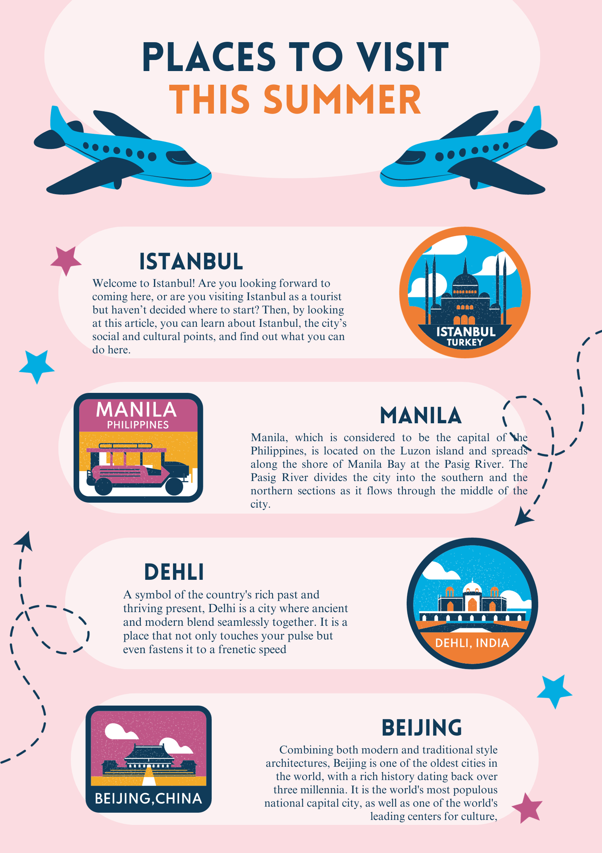

1. Create email newsletter design using Mailchimp or canva tool.